**Windows Activation of VM 2022**

**Purpose**

The purpose of this document is to follow the steps for Windows activation on Windows Server 2022.

**Scope**

This topic provides detailed background information and explains the Windows activation on Windows Server 2022.

**Work Structure -**

1. Verify the connectivity between the VM and Azure KMS service, which is mentioned in below screenshot.

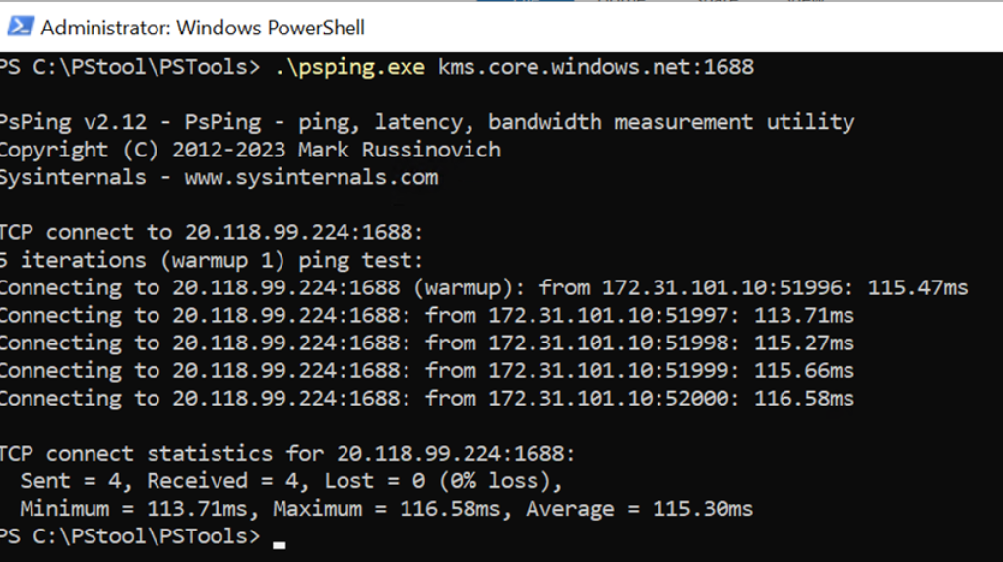

1. Rebuild the token.DAT file by executing below command:  
   net stop sppsvc  
   cd %Systemdrive%\Windows\System32\spp\store\2.0\  
   ren tokens.dat tokens.bar  
   net start sppsvc  
   cscript.exe %windir%\system32\slmgr.vbs /rilc
2. Rebooted the machine.
3. Execute the below command to activate the windows  
   cscript.exe %windir%\system32\slmgr.vbs /ipk \WX4NM-KYWYW-QJJR4-XV3QB-6VM33